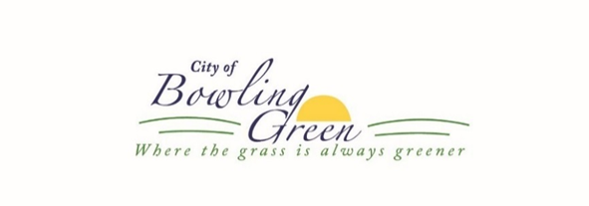
BUSINESS LICENSE APPLICATION

Email- The completed application can be emailed to bgcityhall@bowlinggreen-mo.gov
Or can be mailed/dropped off at:
City Hall- 16 West Church St. Bowling Green, MO 63334 (573)324-5451

In accordance with City ordinances, all businesses located and/or doing business within the City of Bowling Green shall be required to obtain a business license before engaging in or conducting business.
All business licenses expire on June 30th and all renewal applications must be filed by June 15th. Business Licenses must be always displayed at your business.

Additional licenses required for Sale of Liquor, contact our office directly for additional information.

The following items are to be acquired by the applicant prior to the issuance of business license.

- Certifications that all taxes and debts (including utility charges) owed to the City are paid.
- A “NO TAX DUE” form must be obtained from the Department of Revenue and submitted with this application. The applicant must obtain this form within 90 days before the date of submission for application or renewal of the local license. Cities are not permitted to issue business licenses without this form of verification. If you need assistance with this, you may contact the Department of Revenue at (573) 751-9268. If your business does not collect sales tax it is not required to present a statement of no tax due.
- License fee of $25 (made payable to “City of Bowling Green”) must be submitted when turning in the application. The City accepts cash, check, and credit card, which will include an additional 2.49% charge. No guarantee of issuance with payment.
- If you are a contractor in the construction industry, you must supply the City with either a Certificate of Insurance for Workers’ Compensation coverage OR an affidavit from the Division of Workers’ Compensation signed by the applicant attesting that the contractor is exempt form RSMO 287.061. You may obtain this form on the State website at www.labor.mo.gov/DWC/forms/wc-134-Al.pdf.
- If you are in the Massage Therapy business where massages are performed, each massage therapist shall provide to the City a copy of their State License as required by RSMO 324.247. This information is due at the same time as the Business License Application each year.

APPLICATION FOR BUSINESS LICENSE

Business name: ________________________________________________________________________
Address: _____________________________________________________________________________
Mailing (if different from above): __________________________________________________________
Telephone number: ___________________ Email Address: _________________________________
Missouri Tax ID#: _______________________ FEIN: _______________________________________
Cigarette Sales: Yes____ No ____ If yes, please provide a list of your distributors:
____________________________________________________________________________________
Type of Business: (Please check the category that best describes your business)
____Manufacturing ____Agriculture/Forestry/Fishing ____Arts/Entertainment/Recreation
____Retail ____Transportation/Public utilities ____Food Services
____Contractor ____Wholesale ____Storage Units ____Service
____Other (Explain)_____________________________________________________________________

Person making application is: Owner ______ Manager ______ Agent _____
Full name of applicant: _______________________________________________________
Is applicant a U.S. citizen? Yes ____No ______If not, attach documentation of lawful presence in the U.S.

Type of Ownership:
____Individual ____Partnership ____Corporation ____LLC
List the names & addresses of all owners (attach additional pages if needed).
_______________________________________________________________________________________________________________________________________________________________________________________________________________________________________________________________

Have you ever had a bond, business license or any other license or permit suspended or revoked in either this, or any other state? Yes ______ No ______
If yes, please explain ___________________________________________________________
_____________________________________________________________________________

Has the applicant of business ever been convicted of a felony or misdemeanor (other than traffic violations)? Yes ______ No ______ If so, state the dates, charges, and jurisdiction for each conviction:______________________________________________________________________________________________________________________________________________________________________________________________________________________________________________________

I, the undersigned, confirm I am the applicant and hereby declare all above statements to be true and correct. The business to be operated will be conducted in a fair, responsible, and reasonable manner without misrepresentation, fraud, willful misconduct, or false statement. If there are changes or transfers of ownership, changes of address or changes in type of business conducted, the City Clerk will be notified. (If corporation, President and Secretary must sign and affix the corporate seal)

(Corporate Seal) ______________________________
Attest: Signature of Applicant Date
______________________________
Revised 4/1/2021

